**Project Title: Book a Cruise**

Website Name: Cruising Semester: Spring 2019

Group Number: 1

Team Members: Randall Byrd, Riyazh Dholakia, Syed Kalam, Sujal Patel, Biprojoyti Paul Date of Submission: April 22th, 2019

**Problem Statement:**

People who want to go on vacation, have fun, new experience, explore the world, love being on a boat, traveling, food, etc. There are many reasons to go on a cruise. It is also better price wise, compared to flying. Some people feel safer on water rather than flying to places. The audience is endless, since anyone can access site. Our competitors are doing this now. The audience can also be controlled by the market and the client. Sometimes, it is hard to find a cruise booking place. Nowadays, many people want to go to their desired place and wanted to be close to the water and be with the family. The valuable thing is that the cruise gives them all things to a reasonable price. Cruise trips the best trips ever, that incorporate boats, attractions, clubs, family games, and more. People can book plane, car, or go by train, bus, but the fact that Cruise is different than others, tells you more people are will experience this. Anybody would love to be part of an amazing scenery and experience. Other alternatives can also be to book from competitors’ site. The top-level objective is building a product to officiate, booking a cruise. Differentiators from other products is out will be simple, better UX, and other various packages other competitors do not offer. There is a lot of websites and apps already been made on this project. If somebody Googles, they will find many different places to book cruises. We have seen a lot of websites where the look of the website does not appeal as much so that the customer will not be impressed to book the cruise from their website. We made a front-end and back-end/database which will connect to each other. We think we have enough resources to make that possible. If we need help, we can use Google, YouTube, and Udemy courses to sharpen our skills. The front-end system we can built by HTML, CSS, and JavaScript. To make it responsive we will use some jQuery. For database, we will use Firebase. On backend we will use node, JavaScript, hopefully Firebase will take care of server.

It will be fun and challenging to make such kind of project. The fact that we can build a system, which can book ticket with given customer information will be mined blowing, and we can use it later any similar system if we want. This technical idea is common process, hopefully we can introduce new tech into the scene. The fact that we can build a system, which can book ticket with given customer information will be mined blowing, and we can use it later any similar system if we want. This technical idea is common process, hopefully we can introduce new tech into the scene. This is also help us build our skills and gives a good resume project. These skills help us in our future career.

**Class Diagram**

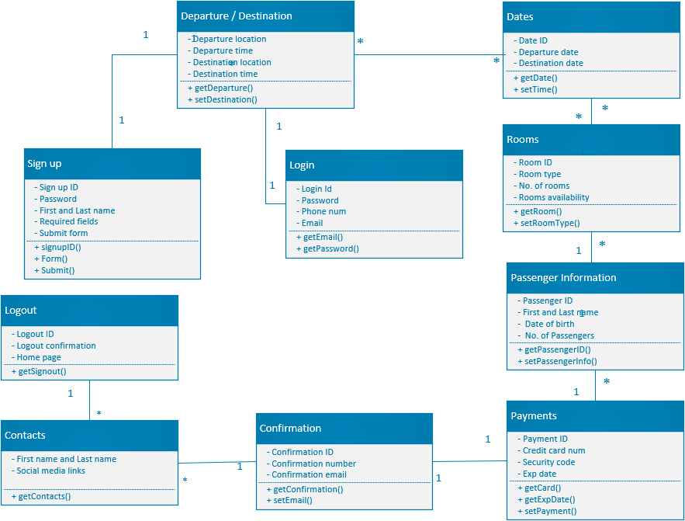

**Sequence Diagram**

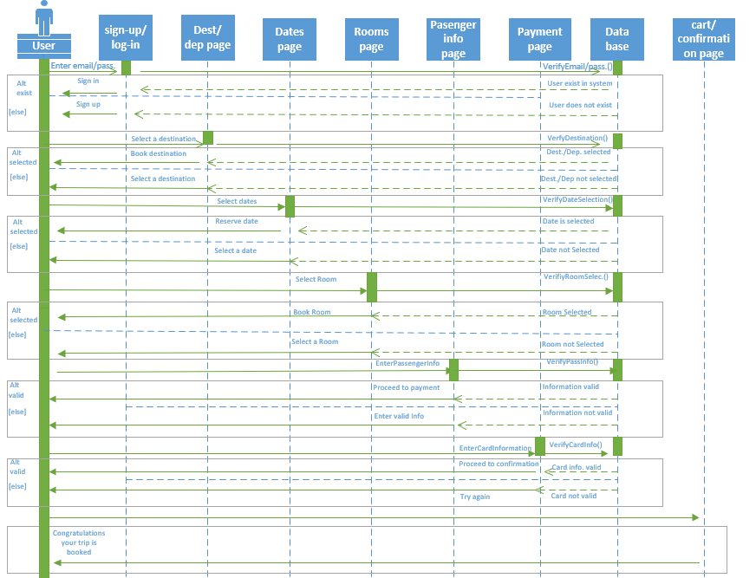

**Front-End**

The front-end framework we used was Bootstrap. It helps to design the pattern and the font style depending on the requirement of the website. It also helps to create the buttons and the navigation bars. We used Bootstrap framework because it allows complete web applications quickly and effectively. It is an open source which helps to generate a clean code, simple and quality. Bootstrap framework depends on the combination of highly development frameworks tested, with the number of features and automations. Different pages mean web pages which can be written in HTML that is accessible through the internet or any other network using internet browser. Web pages are accessible by entering a URL address and may contain text to other web pages and files. Website navigation allows the user to experience site with most efficiency and least incompetence. Website navigation system is more productive to user that they can visit to different areas and information contained within the website. Bootstrap is also a way to make the website format better and makes it mobile-friendly as well. The navigation bar we have currently built in HTML and CSS, but is wrapped in Bootstrap. The different pages in our navigation bar we have is Home, Book Now which is our Destination/Departure page and Contact Us. We have many other pages but that is the flow for booking the cruise. Which we will present and you can see this on our GitHub. Since we are hosting with them as well.

**Back-End**

The backend was designed with Google’s Firebase. It is a NoSQL Database that interacts with JavaScript with an API provided by Firebase. We use this backend because of how easy it is to read and write to the database. It also makes authentication easy as well. Since this is NoSQL database there are no tables and schema. Instead, Firebase uses a JSON tree structure. It makes developing a backend system very simple. To see our JSON structure, we have screenshots of it on our GitHub and as well on previous assignments.

**API**

We did not use any Frameworks besides Bootstrap, which was to make our pages, Front-End. We have Firebase API Key embedded in our JavaScript. No framework is needed with Firebase to make calls to their database. We used Firebase because their API integration with JavaScript is very simple and easy to use. If you see our code, just with couple of line we can make Firebase calls. Only normal JavaScript functions were needed that call on different HTML tags. No special functions are required for Firebase. Feel free to look at our code on GitHub.

**Testing**

Our testing environment used was Jasmine. It tests JavaScript code very quick and easy with there a mix of both Jasmine and my functions. Our major bug was Login button not working. The JavaScript function was not calling the HTML button tag properly. Some problem was within in the function and some was database connection error and some of them was our test code was wrong. So, we manually fix the Database connection, JavaScript function. We also change some of our test code function which one must be true or not to be true.